Output Spreadsheet file:
Combined_AD_and_SAL_Users.csv

Main script:
GetAD_SAL_MoveToOneDrive.ps1
Sub script 1:
GetSAL_From_CloudTrail-WithTags.ps1
Sub script 2:
GetAD_FromS3_Combine_SAL_CSV.ps1

2026-02-27 DP

NOTES: End goal is to have this in the TRACKER_DBZ SQL database instead of just a spreadsheet, so if at some point you realize it would be easier to skip this spreadsheet entirely and just go to SQL we can talk about that.

Scripts live here on the tracker hard-drive: C:\CaribouSoftwareData\SAL_Automation

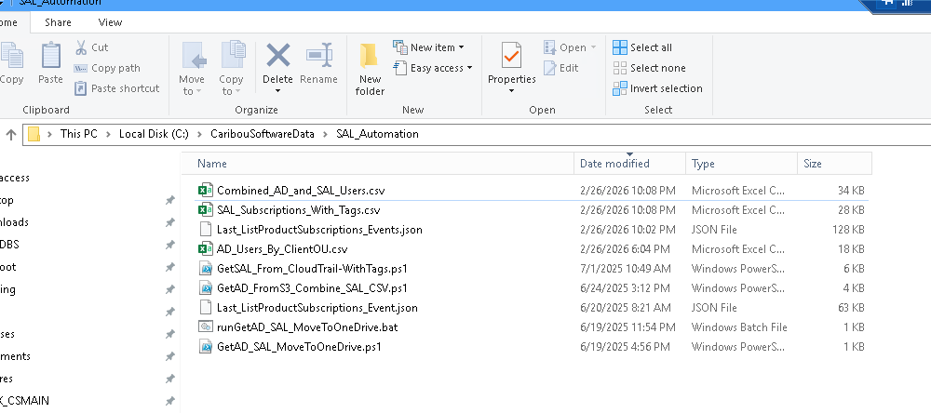

We need to make sure the end spreadsheet doesn't replace "SUBSCRIBED" or "UNSUBSCRIBED" or "AUTOSUBSCRIBED" SAL information with "MISSING"

If there is already a row in the existing spreadsheet, parse what content it has, and if the SAL info currently in it is valid data (SUBSCRIBED for eg) and the SAL info is not present in the current dataset the script is working with from CloudTrail then DO NOT replace it with "MISSING"

Hopefully that makes sense:

